Name: ________________________

Predict Your Water Usage
How much water would you need to do these activities?
Circle the amount you think you would need. If you think you need a LOT of water, you can circle an amount twice.
Activity | Amount of Water
Bath | 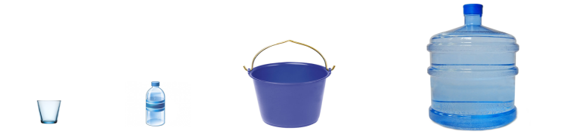
Brush teeth  (tap on) | 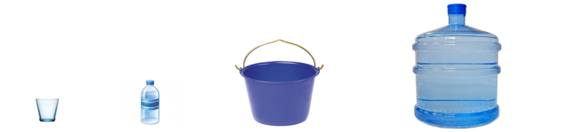
Shower | 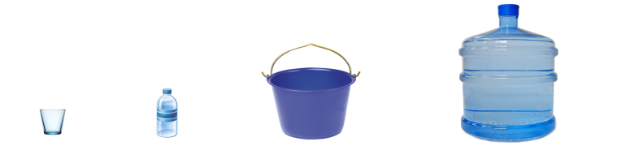
Flush toilet | 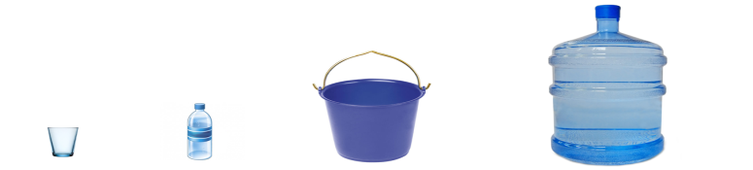
Wash hands or face | 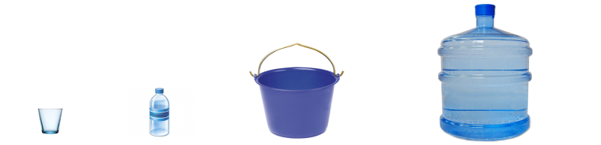
Brush teeth
(tap off)

Drink | 